**HOW TO INSTALL METAMASK AND USE A TEST NETWORK**

**A.) Install MetaMask to your browser.**

> *What is MetaMask?*

**MetaMask** is one of the kinds of cryptocurrency wallets that can be used to **interact with Web3 applications**. Here are the steps to install MetaMask on your browser.

1.) Install MetaMask through their official website. (<https://metamask.io/download/>)

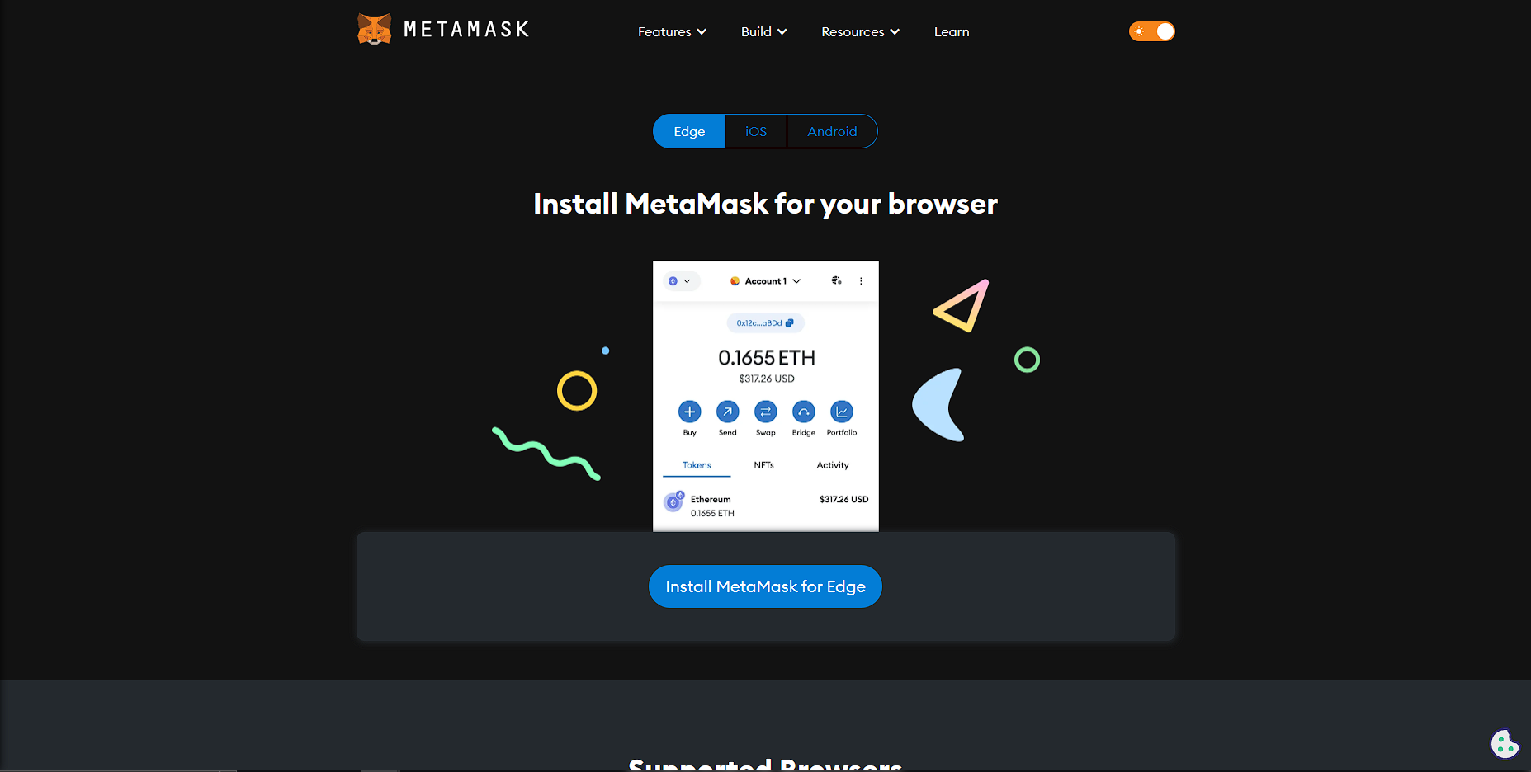

2.) Click the Install MetaMask for Chrome/Edge button.

3.) After clicking **‘Install’**, you will be redirected to the Microsoft Edge Add-ons/Chrome Web Store. Please click **‘Get’** or **‘Add to Chrome’**.

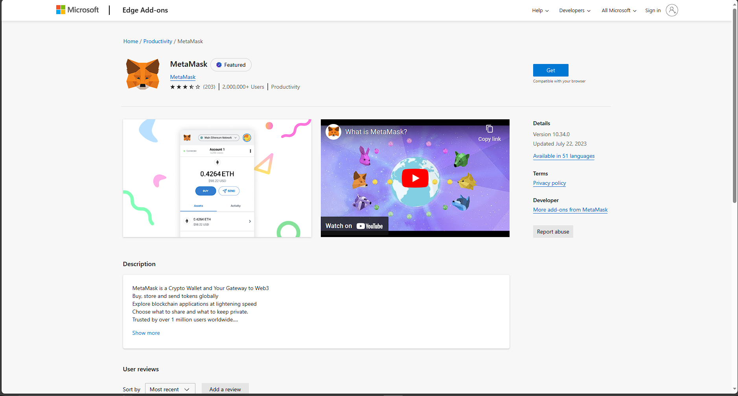

4.) Click **‘Add extension’**.

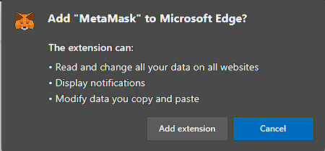

5.) Metamask will **download and install automatically**. Once it is finished, you will be redirected to this page.

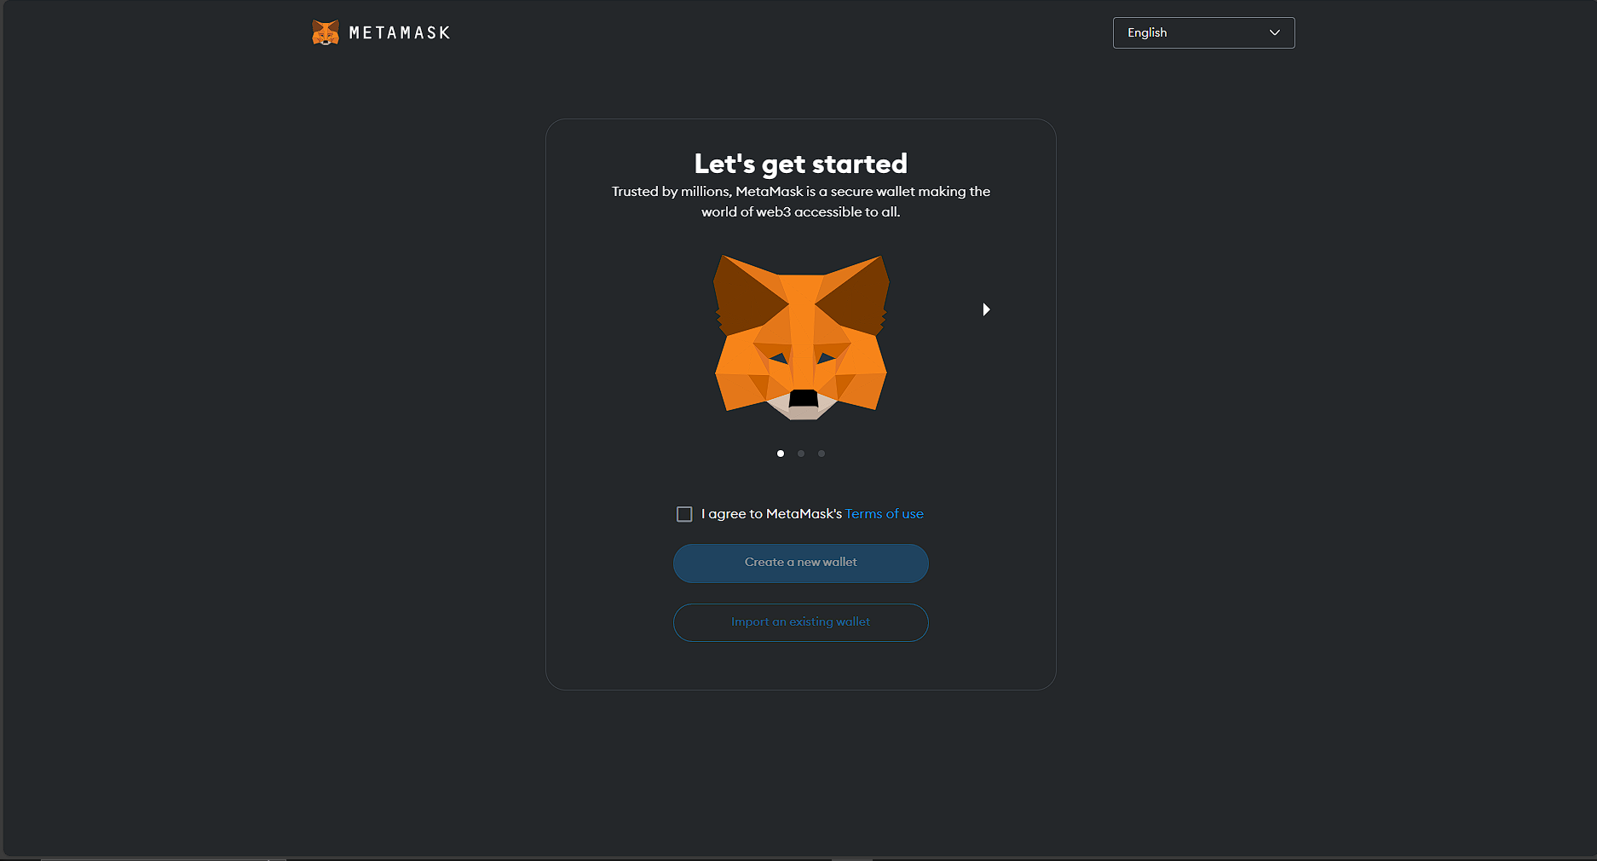

**B.) Creating a MetaMask account.**

1.) Click on the **checkbox** beside “I agree to MetaMask’s Terms of use”.

2.) Click on **“Create a new wallet”**

3.) Click on **“I agree”** and proceed to creating a new wallet.

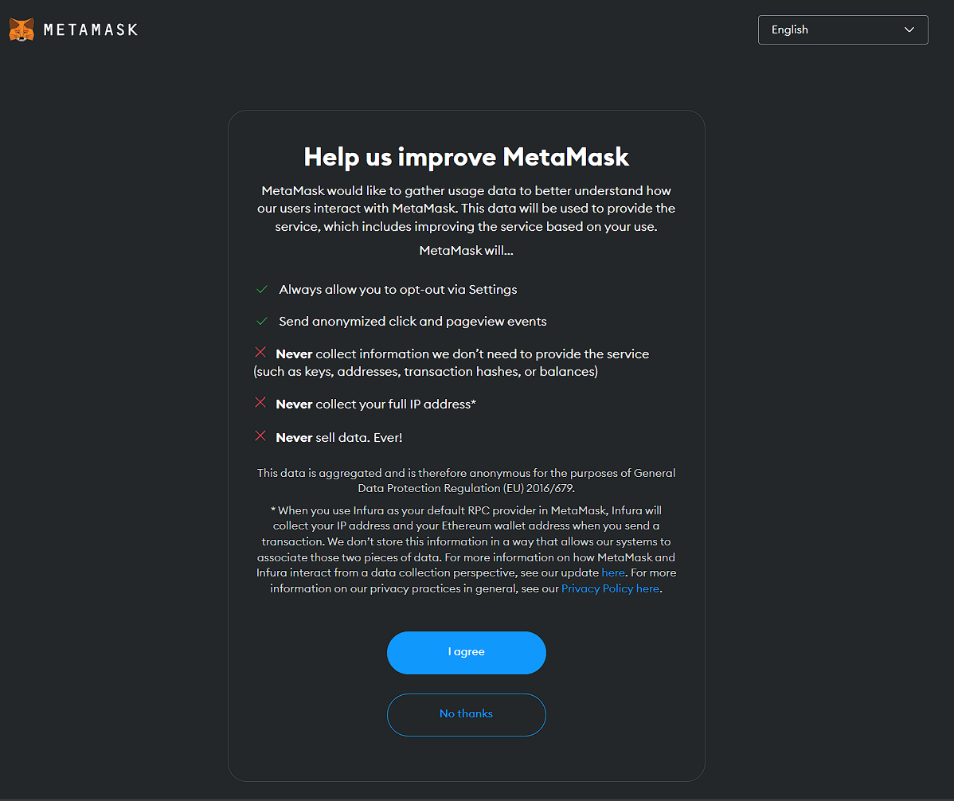

4.) Create a **strong** password.

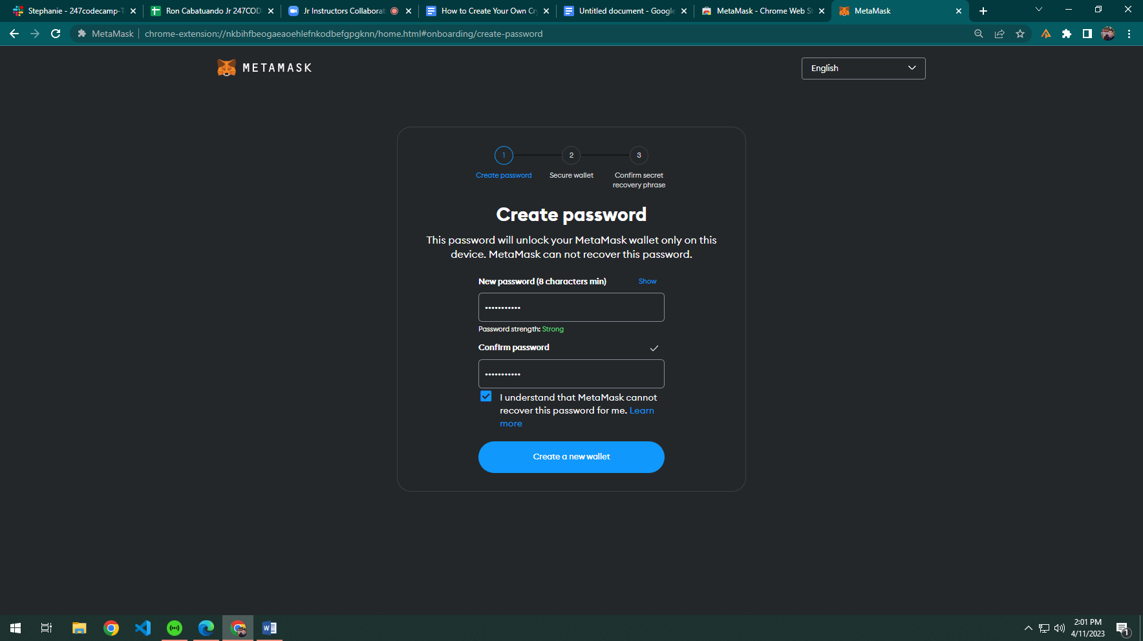

5.) You will be asked if you want to secure your wallet. Press “**Secure My Wallet**”.

6.) Metamask will generate a **12-word secret passphrase**. Store it in a safe place, then click **“Next”**.

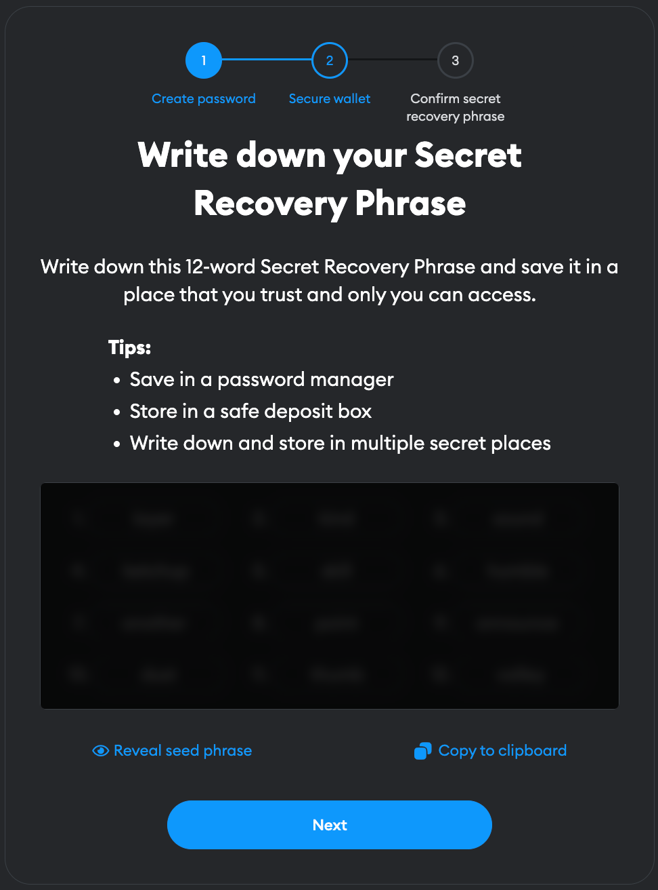

7.) **Confirm** the recovery passphrase by filling out the empty blanks. Then, **the wallet is generated**!

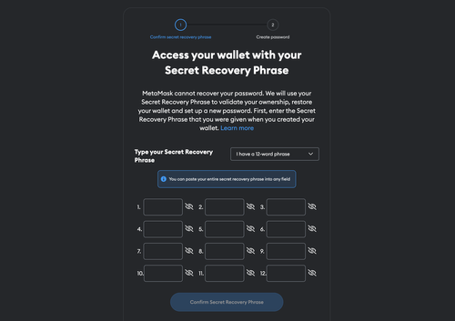

**C.) Adding the Mumbai Testnet through MetaMask**

1.) Visit the ChainList website: <https://chainlist.org/>

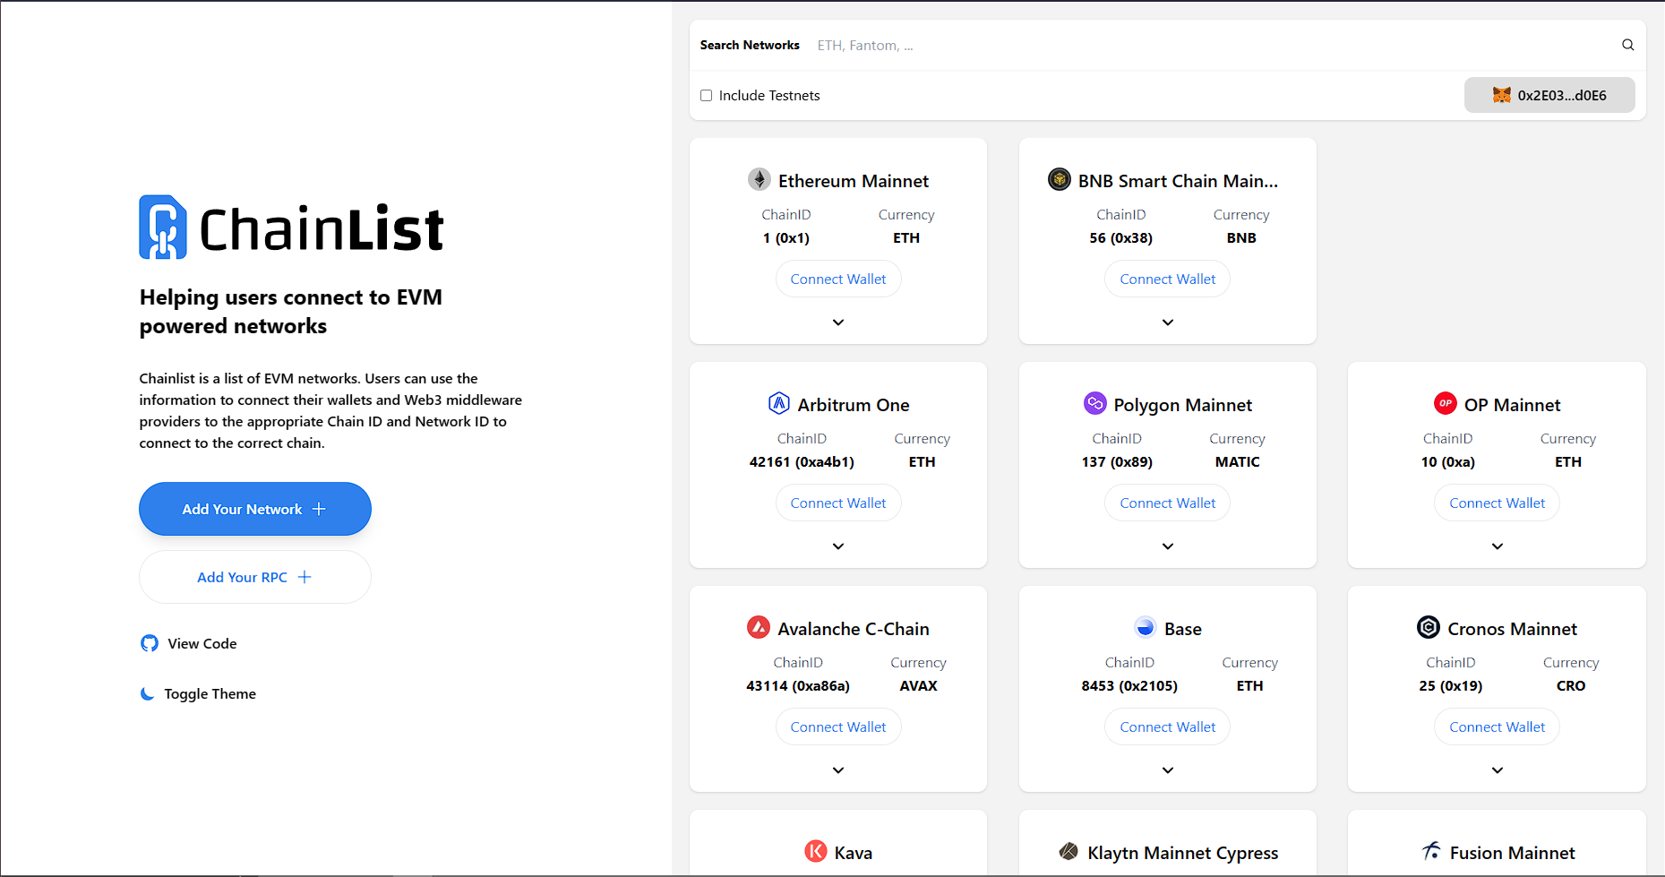

2.) Type **“Mumbai”** in the search box, and click the checkbox to include testnets.

3.) Click the **“Add to Metamask”** button.

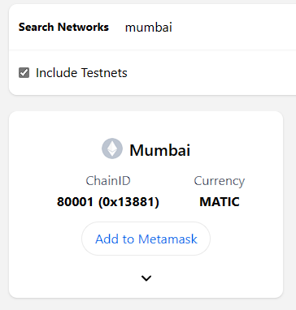

4.) A prompt will appear. Click **Approve** to continue the connection.

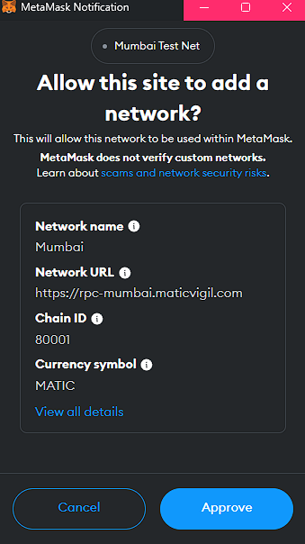

5.) You will be asked to switch networks. Click **“Switch Network”**, then you will see that you are connected to the **Mumbai Test Net**.

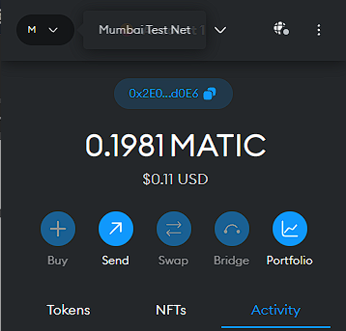

6.) To get some **Mumbai (MATIC)** test tokens, go to [Mumbai Faucet](https://mumbaifaucet.com/) and paste your MetaMask public address **(click on the blue pill button starting with 0x)** in the **textbox** (Enter Your Wallet Address (0x...)).

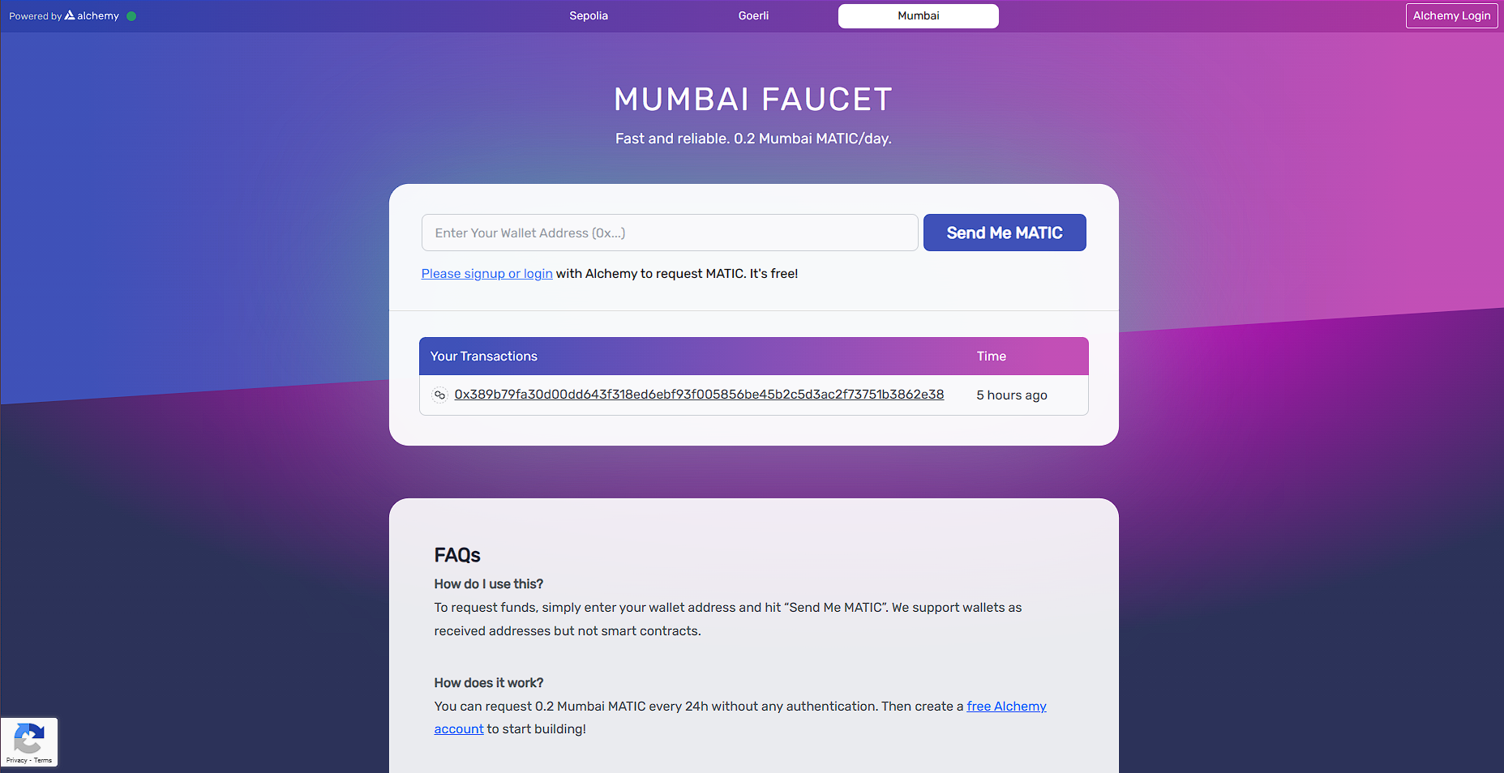

7.) Click on **‘Send Me MATIC’** and you’ll be able to receive some test tokens. You now have a mumbai test network along with some MATIC test tokens. **Congratulations!**